Twelve Reasons Why Even Very Good Christians Misunderstand Bible Prophecy
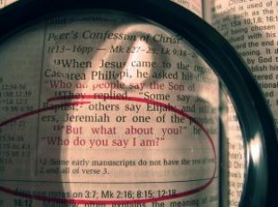
by John Edmiston

There have been hundreds of failed attempts to predict the end of the world or the Rapture. Many of these attempts have been made by sincere, studious, intelligent, born-gain, bible-believing, Spirit-filled Christians who often gave decades of their life to poring over the Scriptures – but every single one of them has been in error!

With some recent highly publicized failures in the “dates and times” area there has been renewed interest in why otherwise good people make very bad prophets. (I am not interested in explaining the errors of charlatans or racketeers). Indeed over the centuries a wide range of people - including mystics, geniuses and well-known Christians have been wrong about the End Times. There is something very strange going on here!

After some reflection I have come up with a dozen or so reasons why godly, sincere, intelligent students of the End Times nearly always “get it wrong”.

- God Limits Our Knowledge By His Sovereign Will - God keeps certain information to Himself. This is His prerogative, in fact we can only know that which God gives us to know:
Acts 1:7 And He said to them (the apostles), It is not for you to know the times or the seasons, which the Father has put in His own authority.
Matthew 24:35-36 The heaven and the earth shall pass away, but My Words shall not pass away. (36) But of that day and hour no one knows, no, not the angels of Heaven, but only My Father.
Deuteronomy 29:29 The secret things belong to Jehovah our God, but the revealed things belong to us and to our sons forever, so that we may do all the words of this Law.
- We Don't Have The Whole Picture - In fact we might have only 0.01% of the picture if we are lucky! The Universe is like a multidimensional trillion-piece jigsaw puzzle that assembles itself through time, and we might have say about 2000 pieces. The 2000 pieces we do have are good and true and we can trust them - but any large picture we try to assemble out of them will be limited, partial and incomplete.
1 Corinthians 13:9-12 For we know in part, and we prophesy in part. ... For now we see in a mirror dimly, but then face to face. Now I know in part, but then I shall fully know even as I also am fully known.
Ecclesiastes 8:17 Then I looked at all the work of God, that a man cannot find out the work that is done under the sun; because though a man labors to seek it out, yet he shall not find it. Yea, further, though a wise one speaks of knowing, yet he shall not be able to find it.
Ecclesiastes 11:5 As you do not know what is the way of the spirit, as how the bones grow in the pregnant woman's womb; even so you do not know the works of God who makes all.

- We Are Assembling The Picture In The Wrong Way - Imagine someone who had never seen an orange and was given 100 pieces of a complete orange peel on a kitchen bench and asked to reassemble the original object as a sort of jigsaw puzzle. Most people would take the fragments of orange peel, lie them flat on the bench and then try to push them around so they fitted more or less together. The resulting object would be flat, that is a plane and not a sphere, because they used a flat plane surface as the area in which to to assemble their pieces. Their innocent mistake would come about because their frame of reference was flat and linear, not spherical and hollow.
When we try and use the Greek logic of Plato and Aristotle to assemble Christian theology we end up with a very flat, linear picture; one that is completely the wrong shape! Scripture is assembled around Jesus Christ, who is the image of God, and not around any philosophical, rational, national, racial or chronological framework.
This was the problem of the Pharisees who studied the Scripture from a Jewish nationalistic framework and refused Jesus because He did not fit their theory. Similarly the Sadducees (who studied the Bible from a legal, ritualistic, and Greek philosophical point of view) also failed to see Jesus as the Messiah!
John 5:39-40 You search the Scriptures, for in them you think you have eternal life. And they are the ones witnessing of Me, and you will not come to Me that you might have life. [said to the Pharisees]

Matthew 22:29 Jesus answered and said to them, You err, not knowing the Scriptures nor the power of God. [said to the Sadducees]
John 7:52 They answered and said to him, Are you also from Galilee? Search the scriptures and see that a prophet has not been raised out of Galilee. [The high priest misunderstanding Jesus's birthplace]

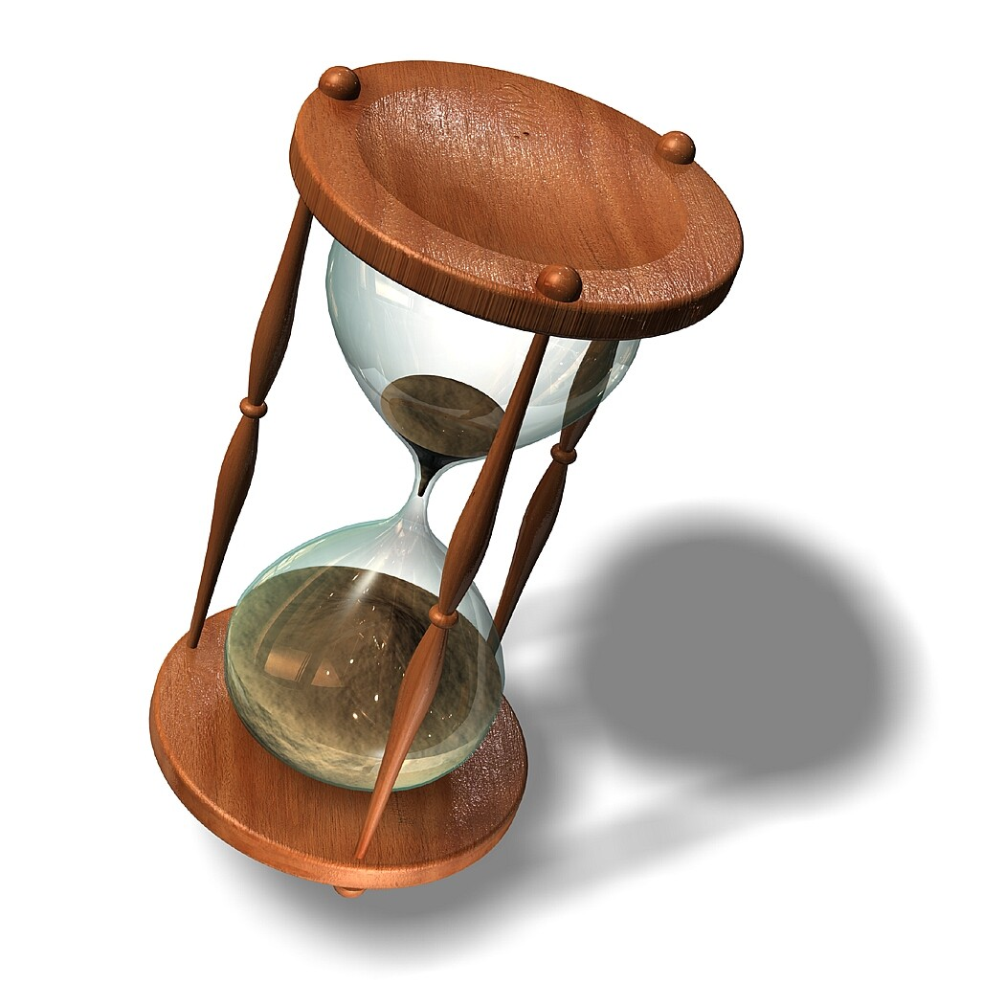

- God's Idea Of Time Is Nothing Like Our Idea Of Time - God created the Universe, and space, time and matter were all created by Him, through Jesus Christ. Thus time is a created thing and God is not subject to it. In fact God is not ruled by any clock at all. For the Lord one day can be as a thousand years or a thousand years as one day (2 Peter 3:8). God stopped the sun for Joshua and “there was no day like it”. (Joshua 10:12-14) God can arrange time any way that he wishes and even do things immediately, in an absolute instant (Mark 1:31, 42, 5:29 etc) The Greek word tachos / tachu used with respect to prophecy means that events in the last days will come about very quickly, in a powerful rush of events as if history is suddenly sped up to a frenetic pace. God can hasten things in their time (Isaiah 60:22). God operates from eternity and when eternity intersects our time axis strange and wonderful things happen. God can even do a thousand years worth of evangelism in a single day! God can and does make things happen in a certain chronological order and even to the precise moment. He does this for His glory. Yet God is not bound to any man's schedule or to any human being’s interpretation of when He should do things.
- We Get Eternal “Event Time” And Historical “Calendar Time” Confused – there are two ways in which events are generally sequenced a) Event Time: that is in order one after the other with no specific reference to time e.g. 'After dinner we will wash up and then watch TV”. Dinner might take ten minutes, twenty minutes or three hours, it does not matter, the next thing will be washing up, and after that watching TV. Since God dwells in eternity where clock time is irrelevant, He most often uses event time as His scheduling mechanism.
Event time is indicated by words such as : then, immediately, after, until, before, first, last, and suddenly.
The word “then” indicates exact sequential order”:
Matthew 24:14 And this gospel of the kingdom shall be proclaimed in all the world as a witness to all nations. And then the end shall come.

2 Thessalonians 2:7-8 For the mystery of lawlessness is already at work. Only he who now restrains it will do so until he is out of the way. (8) And then the lawless one will be revealed, whom the Lord Jesus will kill with the breath of his mouth and bring to nothing by the appearance of his coming.


The word “after” indicates a general order in which one happens in order after the other, but may be separated by large chunks of time:
Revelation 7:1 And after these things I saw four angels standing on the four corners of the earth, holding the four winds of the earth so that the wind should not blow on the earth, nor on the sea, nor on any tree.

Revelation 9:12 The first woe is past. Behold, after these things yet come two woes.

Acts 15:16-18 "After this I will return and will build again the tabernacle of David which has fallen down; and I will build again its ruins, and I will set it up, (17) so those men who are left might seek after the Lord, and all the nations on whom My name has been called, says the Lord, who does all these things." (18) All His works are known to God from eternity.
The word “until' gives us a condition that has to happen before the next thing can occur and is also a marker for God's event-time scheduling.

Revelation 7:3 saying, Do not hurt the earth or the sea or the trees until we have sealed the servants of our God in their foreheads.

Revelation 17:17 For God gave into their hearts to do His mind, and to act with one mind, and to give their kingdom to the beast until the Words of God will be fulfilled.

The word “before” like “until” indicates what prior things must take place and the two words are sometimes used together:

1 Thessalonians 4:15 For we say this to you by the Word of the Lord, that we who are alive and remain until the coming of the Lord shall not go before those who are asleep.


The words “first” and “last” also help set God's event-time schedule:

2 Thessalonians 2:3 Let not anyone deceive you by any means. For that Day shall not come unless there first comes a falling away, and the man of sin shall be revealed, the son of perdition,

Revelation 15:1 Then I saw another sign in heaven, great and amazing, seven angels with seven plagues, which are the last, for with them the wrath of God is finished.

And words like “already” and “now” indicate that something has occurred or is already working even in the Church Age:
Matthew 17:12 But I tell you that Elijah has already come, and they did not recognize him, but did to him whatever they pleased. So also the Son of Man will certainly suffer at their hands."

2 Thessalonians 2:7 For the mystery of lawlessness is already at work....

The words “immediately” and “suddenly” indicate that once one thing is accomplished another will occur straight afterward and often with great power:

Matthew 24:29 "Immediately after the tribulation of those days the sun will be darkened, and the moon will not give its light, and the stars will fall from heaven, and the powers of the heavens will be shaken.
1 Thessalonians 5:2-3 For you yourselves are fully aware that the day of the Lord will come like a thief in the night. (3) While people are saying, "There is peace and security," then sudden destruction will come upon them as labor pains come upon a pregnant woman, and they will not escape.

Luke 21:34-35 "But watch yourselves lest your hearts be weighed down with dissipation and drunkenness and cares of this life, and that day come upon you suddenly like a trap. (35) For it will come upon all who dwell on the face of the whole earth.

As you can see there are hundreds of such event-time sequence verses in the Bible and they indicate the exact order of God's events. However they are frequently ignored because we have such a strong cultural bias for exact numbers. We prefer clock-time and calendar time and the focus tends to be on terms such as Daniel's seventieth week, three and a half years and the 1260 days. Given the symbolic use of numbers in the Bible we must give the clearly indicated event time order and sequencing much higher priority - for it is more certain!


- God Uses Public Key Cryptography! - The Bible is not a plain book that can be understood by the fallen human “carnal” mind, for it is “foolishness” to such a person (1 Corinthians 2:14-16). Rather it is an encrypted message which has a key, or in this case three keys – the person of Christ, the illumination of the Holy Spirit and the witness of Creation. The Bible is encrypted by God, it is one half of a big secret! To understand the secrets of God we must first be born-again and Spirit-filled our eyes must be fixed on Christ who is above (Colossians 3:1-4) and we must observe Creation (such as the lilies of the field and the birds of the air) as confirmation that our conclusions match reality. God's method of encryption is very similar to public-key cryptography in which a hidden private key decrypts the “other half” of the message. Here is a definition from PC Magazine:
Public Key Cryptography is: An encryption method that uses a two-part key: a public key and a private key. To send an encrypted message to someone, you use the recipient's public key, which can be sent to you via regular e-mail or made available on any public Web site or venue. To decrypt the message, the recipient uses the private key, which he or she keeps secret.
The bible is the “public key” to reality, to prophecy and to our existence but it needs the spiritual, hidden, “private keys” of Christ, and of the anointing to unlock the public key of Scripture. These private keys are hidden in God and require relationship with Him!
The Bible cannot be decoded by any computer program or numerical system but only through relationship with God. Relationship with God involves having a new Spirit-filled nature, being obedient, and checking our conclusions against God's great message in Creation. The liberal scholars of the 19th and early 20th centuries tried studying the bible as “literature” and ended up as unbelievers! The human mind cannot crack Scripture by rational means.
The Bible helps us make sense of life, it decrypts our puzzling existence. In turn the Holy Spirit, the image of Jesus Christ and the glory of creation help us to decrypt prophecy. Thus, any attempt to reduce prophecy to a purely intellectual exercise is bound to fail because the Book is sealed and encrypted!
John 7:16-17 So Jesus answered them, "My teaching is not mine, but his who sent me. (17) If anyone's will is to do God's will, he will know whether the teaching is from God or whether I am speaking on my own authority.
1 John 2:27 But the anointing that you received from him abides in you, and you have no need that anyone should teach you. But as his anointing teaches you about everything, and is true, and is no lie--just as it has taught you, abide in him.
1 Corinthians 2:14-16 The natural person does not accept the things of the Spirit of God, for they are folly to him, and he is not able to understand them because they are spiritually discerned. (15) The spiritual person judges all things, but is himself to be judged by no one. (16) "For who has understood the mind of the Lord so as to instruct him?" But we have the mind of Christ.

- Prophecy Generally Only Becomes Clear When The Reality That It Refers To Appears On The Scene of History – The prophecies about the Messiah were unclear to the Jews until Jesus came on the scene of history and made sense of them. In fact the Jews expected two Messiahs one a suffering Messiah (ben-Joseph) and one a victorious Messiah (ben-David). Jesus was both and it was through his suffering that he was victorious and took up the throne of David. The reality manifested and clarified the prophecy, the “type” was fulfilled in the “anti-type” the “shadow” became solid in the “substance”.
Similarly the prophecies about Gog and Magog must have seemed peculiar to the prophet Ezekiel. Why would Libya or Russia attack Israel ? They had never done so in Ezekiel's time! But today the nations of Ezekiel 38 & 39 are a vast Islamic and Communist conspiracy and are violently anti-Israel! The prophecy finally makes sense and is probably going to be fulfilled in the not-too-distant future. Prophecy is like a coin broken into two halves, when the other half is found (in history) suddenly the coin is 'whole” and the picture makes sense!
Colossians 2:16-17 Therefore let no one pass judgment on you in questions of food and drink, or with regard to a festival or a new moon or a Sabbath. (17) These are a shadow of the things to come, but the substance belongs to Christ.

Hebrews 8:5-6 They serve a copy and shadow of the heavenly things. For when Moses was about to erect the tent, he was instructed by God, saying, "See that you make everything according to the pattern that was shown you on the mountain." (6) But as it is, Christ has obtained a ministry that is as much more excellent than the old as the covenant he mediates is better, since it is enacted on better promises.
Romans 5:14 Yet death reigned from Adam to Moses, even over those whose sinning was not like the transgression of Adam, who was a type of the one who was to come.


- God Generally Only Reveals To a Person What They Are To Do Next Or The Meaning Of The Thing They Are Personally Called To Do – Jesus seemed to only give instructions to His disciples about the 'next thing' they were to do – casting a net off the boat, following Him, bringing some loaves and fishes, receiving the Holy Spirit or going into all the world to preach the gospel!
In Acts 10 when the Holy Spirit wanted Peter to go to the Gentiles He first instructed the apostle to eat some unclean food, then go downstairs, then go with some men, then finally to preach the gospel in another city. Similarly in Acts 8 Phillip is given “one-step at-a-time' instructions in meeting the Ethiopian eunuch. In Acts 16 God calls Paul and Silas to Macedonia in a simple step of obedience when they did not know what to 'do next”. Most of the time God just gives us that small bit of the picture that we need to be part of at that moment in time. God does not give us the whole battle plan – just the orders that we need to follow!
The main lesson that we get from prophecy is that we should be holy and faithful and diligently carry out the work of God. The battle is the Lord's, not ours, and our main role is just to be obedient, loyal soldiers who endure hardship for Christ Jesus and who are rewarded on the Day of His appearing.
God uses prophecy to help us understand the meaning and purpose of our calling and to paint the big picture of the battle that we are part of in the heavenly realms. However we cannot apply all of prophecy to ourselves as if we knew the whole master plan, but must seek the Lord for His commandments for our lives.

- God Has Designed The Universe To Be Not Completely Predictable -
Even the very simplest of things will become unpredictable over time. For instance imagine someone throwing a golf ball down hard on to smooth concrete. The first two bounces will be somewhat predictable but the third will be hard to guess and the sixth or seventh bounce will probably be different each time he or she attempts the experiment.
Despite our best attempts at computer modeling, intelligent long-term predictions about any complex phenomena such as the weather, sports results or the stock market have proved fruitless. In fact the stock-market is described mathematically as a “random-walk”! Generally the further out in time events are (the more “bounces” along the sequence) the more unpredictable they become.
Since the whole Universe has this unpredictability about it, we can surmise that it is God's deliberate design. God does this so that we are forced to trust Him because we do not know the future – or even the day of our death! Indeed we are called to walk by faith! (2 Cor. 5:7)
Ecclesiastes 9:11-12 Again I saw that under the sun the race is not to the swift, nor the battle to the strong, nor bread to the wise, nor riches to the intelligent, nor favor to those with knowledge, but time and chance happen to them all. (12) For man does not know his time. Like fish that are taken in an evil net, and like birds that are caught in a snare, so the children of man are snared at an evil time, when it suddenly falls upon them.

Ecclesiastes 11:6 In the morning sow your seed, and at evening withhold not your hand, for you do not know which will prosper, this or that, or whether both alike will be good.
Matthew 24:42 Therefore, stay awake, for you do not know on what day your Lord is coming.

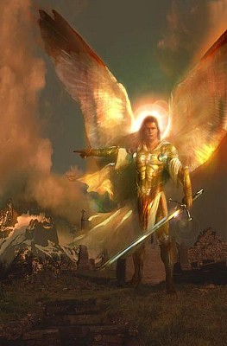
- We Are Largely Unaware Of The Spiritual Dimension In Human Affairs -
The classic case of this is Job who was completely unaware of Satan's manipulation of events and who thus found his painful situation (and God's ways) totally confusing and incomprehensible. God's basic answer to Job was: “Job, you know nothing at all about what is going on in the Universe so don't question what you don't know! However I, YHWH have turned up to personally meet you and you can sense that I love you and have entered into relationship with you so its going to be OK, now get on with life and pray for your friends who are even more clueless than you!”. We get other hints about the complexity of the spiritual universe in Daniel and in Zechariah and find out about beings such as the heavenly watchers who preside over human affairs. The New Testament tells us that the Christian's life is a demonstration of God's wisdom to the heavenly realms (Ephesians 3;10).
A helpful analogy (though an imperfect one) is that we are being observed from heaven through the one-way mirror of the disarmament. Everything we do is being entered into books in Heaven by recording angels. Even the hairs on our head are numbered. Somehow our choices, especially our moral choices, matter to the powerful spiritual beings who inhabit those realms.
One dimension of prophecy is this “war in Heaven” that plays out even in the fate of nations, and especially in the destiny of the nation of Israel. The war on the ground is often just the outcome of the war in the spirit – as in Joshua's victory over the Amalekites through the prayers of Moses and Joshua's defeat at Ai through the spiritual failure of Achan.
This is all outside of our modern scientific world-view and so we end up over-simplifying our interpretation of prophecy. Some see prophecy just as God drawing up exact plans and then putting them into action in an exact time-table, a bit like a landscape gardener fulfilling a beautification plan. Unfortunately there is (spiritual) artillery (from Satan) landing at the same time that God the gardener is trying to plant the roses! The fulfillment of prophecy involves a dynamic interaction between God and His angels, Satan and his angels, the Church, the sinful world, kings and nations and so on and so forth. God will win and Jesus will return and not one word of the Lord will fall to the ground, nonetheless we need to realize that our picture of events may be over-simplified and sometimes mistaken.
Ephesians 6:12 For we do not wrestle against flesh and blood, but against the rulers, against the authorities, against the cosmic powers over this present darkness, against the spiritual forces of evil in the heavenly places.
Revelation 12:7-9 Now war arose in heaven, Michael and his angels fighting against the dragon. And the dragon and his angels fought back, (8) but he was defeated, and there was no longer any place for them in heaven. (9) And the great dragon was thrown down, that ancient serpent, who is called the devil and Satan, the deceiver of the whole world--he was thrown down to the earth, and his angels were thrown down with him.


- If Prophecy Was Easy To Figure Out Then Satan Would Be Fully Aware Of All Of God's Plans
Satan is a very ancient, deeply malignant being who knows Heaven, Hell and the Scriptures, and who knows how people act and react. He has many angels under his command and can assign them to find out what prophecy means. He knows the original languages and ancient events better than we do and understands all the feast days and calendars. If prophecy could be unlocked by normal investigative means Satan would have figured out all the details of God's plans long ago.
Therefore God only reveals enough of His plans for the average Christian to hold on and have faith in a God who is Lord of History and who fulfills His Word exactly. For instance the details of the Church, Pentecost, the inclusion of the Gentiles and the Great Commission were closely kept “mysteries” that were only revealed after the Resurrection. Angels “long to look” into the mysteries of salvation and the end times, but they are kept back from them! This is possibly because of the heavenly war that is raging.
If we could figure it out and put in a book, then the Devil could read that book and work out what to do next. God doesn't give us the total plan because He does not want the Devil finding it out until its too late!
Romans 16:25-27 ... according to the revelation of the mystery that was kept secret for long ages (26) but has now been disclosed and through the prophetic writings has been made known to all nations, according to the command of the eternal God, to bring about the obedience of faith...
1 Peter 1:12 It was revealed to them that they were serving not themselves but you, in the things that have now been announced to you through those who preached the good news to you by the Holy Spirit sent from heaven, things into which angels long to look.

- The Purpose Of Prophecy Is Not Knowledge, Politics Or Prediction But Faith, Hope And Love – God does not give us His very precious Word just so that we can know the right moment when we are to sell our shares and buy gold! Or so that we can back the right political candidate or avoid the wrong one. The purpose of prophecy is to reveal the Spirit of Christ, which is the Spirit of prophecy and to build hope, faith and love in the hearts of God's saints so that we walk in purity and the fear of the Lord. Many of the most dire prophetic passages in the New Testament are followed by a call to repentance and to holy living! (see 2 Peter chapter 3 as a perfect example of this!). Indeed most of the end-times parables are followed by a call to faithfulness, watchfulness and prayer or to diligence in ministry and the stewardship of His grace.
Prophecy is not about gaining knowledge and through such knowledge gaining power over our circumstances. That is more akin to ancient Gnosticism or Jewish Kabbalah than it is to genuine Christianity.
One possible interpretation of the tree of the Knowledge of Good and Evil is that it involved fortune-telling, that is the ability to know if good or evil was going to happen and thus avoid it, thus replacing any need for faith and trust in God. The knowledge of good and evil events in advance, foresight of good and evil, or prophetic ability used for personal comfort without reference to God, and this is known as “divination”. (Adam was made in the image of God so he certainly had a conscience and knew good from evil in that sense even before the Fall. This sinful knowledge of good and evil was something different, and was a god-like spiritual ability that made Eve “like God” knowing the future).
The use of Bible prophecy primarily to predict current political and economic events comes perilously close to this “knowledge of good and evil' and to the iniquity of personal divination (Deuteronomy 18:10-14, Leviticus 19:26)! Some of those trying to interpret bible prophecy are actually looking more to their own predictive powers than to being holy, godly and righteous.
The purpose of the Scriptures are to testify to Jesus Christ (Luke 24:27) and to bring God's people into obedience to the truth so that they walk in faith and love in the Holy Ghost (2 Timothy 3:16,17).
If we ever lose sight of this we can go astray!
CONCLUSION
We should definitely study bible-prophecy because:
- Prophecy declares to us the sovereign majesty of God and His revelation in Christ Jesus and calls us to holy living and inspires hope, faith and confidence in the believer.
- Prophecy shows us that God's promises are sure and are fulfilled. Prophecy is as a light shining in a dark place, (2 Peter 1:19-21) lighting up the future with hope in God's goodness, justice and mercy.
- Prophecy tells us that God will win in the end and that we are part of a cosmic struggle, that our every action is significant, and that we should walk in holiness and fear of the Lord.
- Prophecy clearly delineates between good and evil, and shows us that eternal reward and eternal punishment are real and the moral Universe is powerful and should direct our living.

- Prophecy also tells us clearly that this world is passing away and that we are not to hanker after it but to seek the Kingdom of God and His righteousness (Matthew 6:33).
Bible-prophecy is a spiritual calling to be obediently followed not a clever conundrum to be solved. We are to believe prophecy and to obey prophecy but we cannot “figure-out” prophecy for all of the twelve reasons that are mentioned above.
Therefore all End Times “road-maps” that pretend to some absolute knowledge of dates and times are wrong and have always been wrong.
Acts 1:7 ... It is not for you to know the times or the seasons, which the Father has put in His own authority.
[This article is © copyright John Edmiston, 2011 – However it may be freely used for non-profit ministry purposes, but may not be sold in any way}

